Chapter 1.4.2 Execution environments for your Application

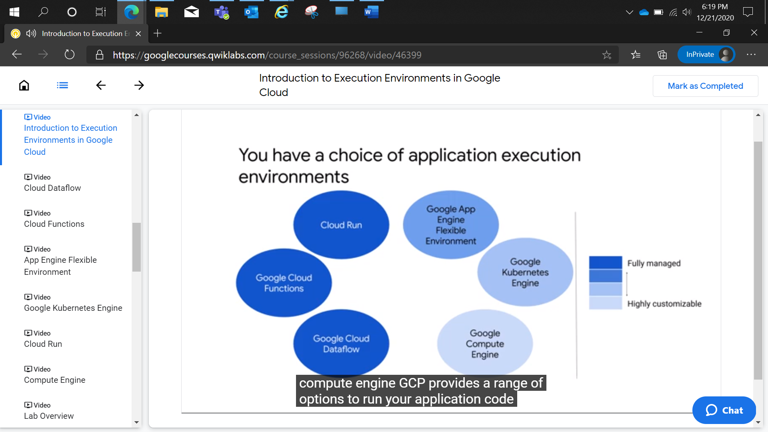

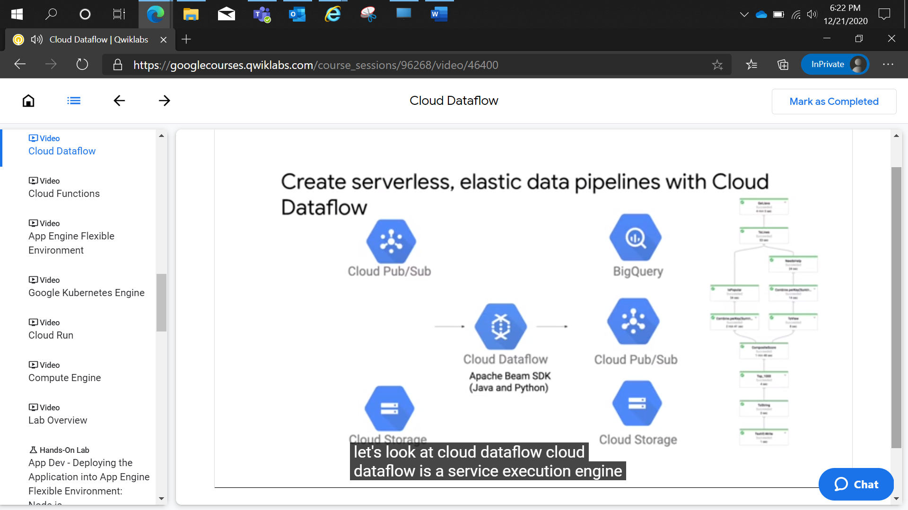

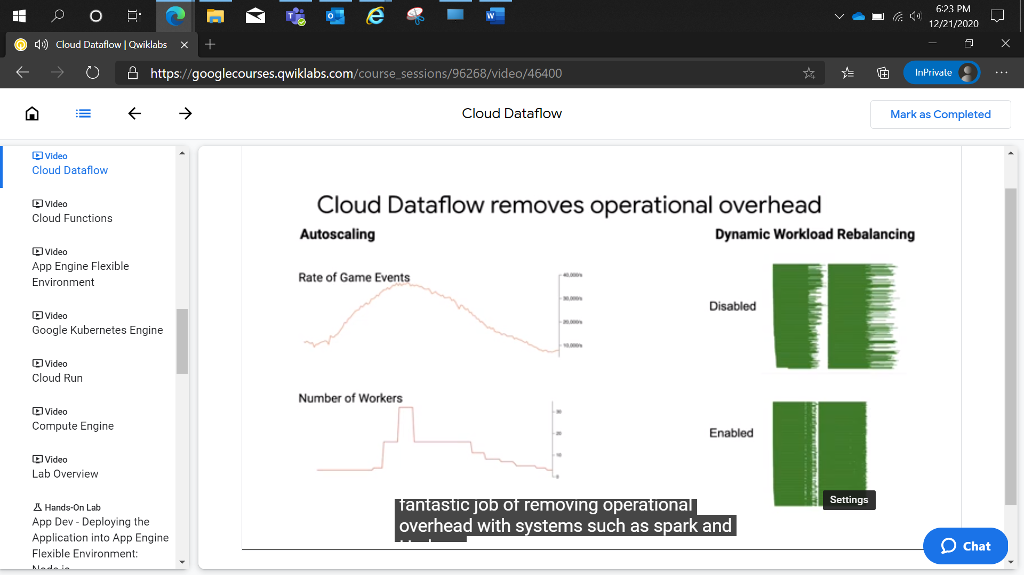

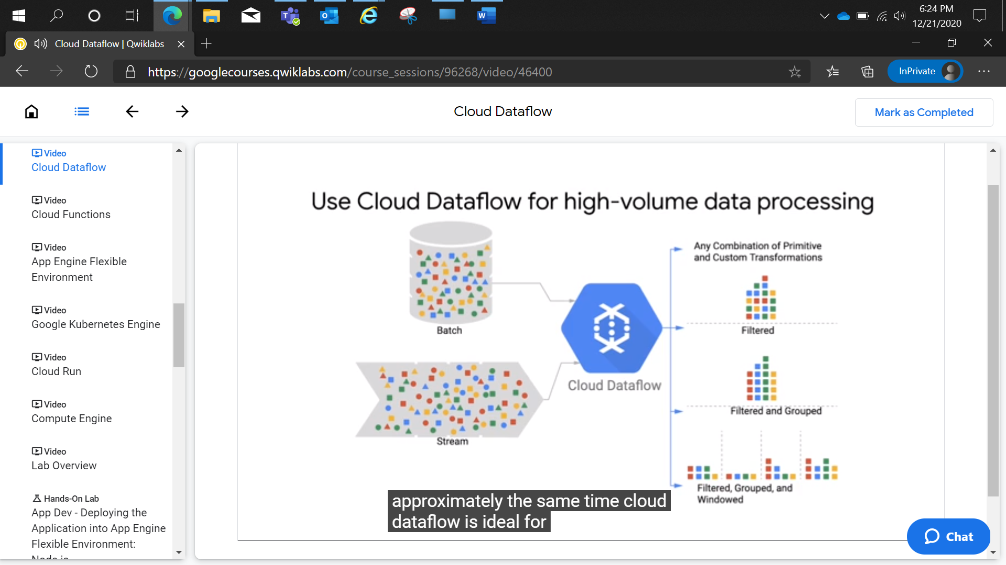

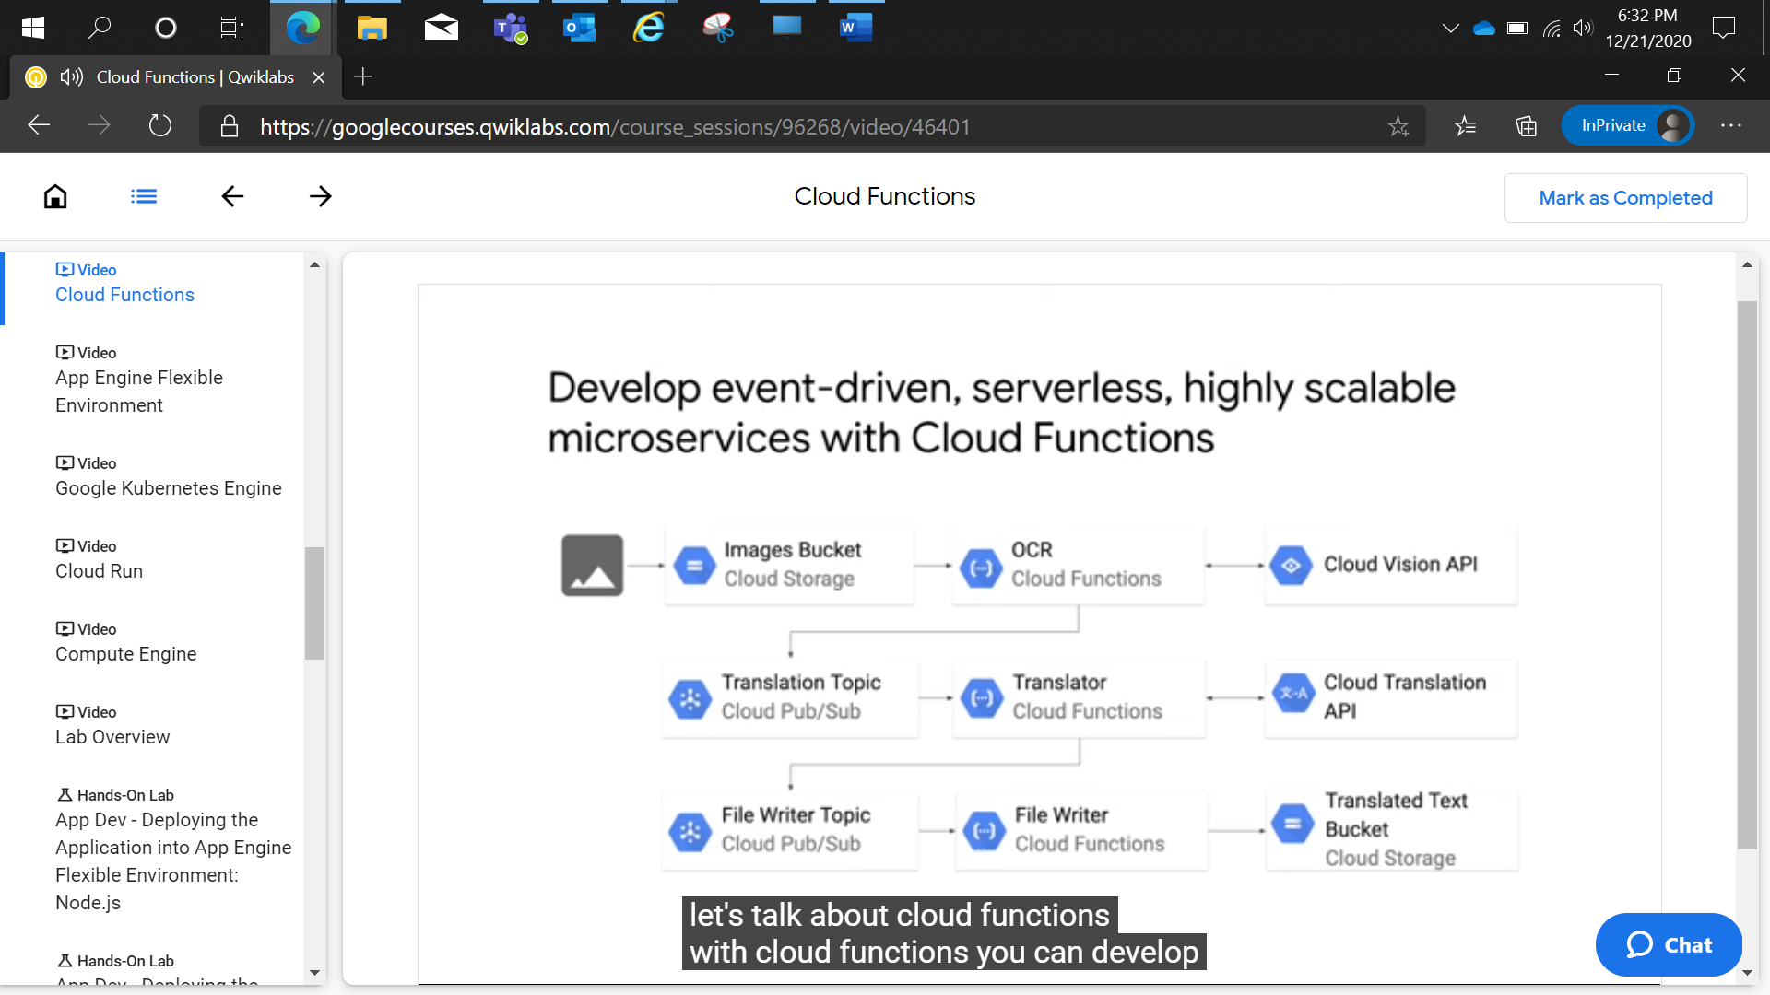

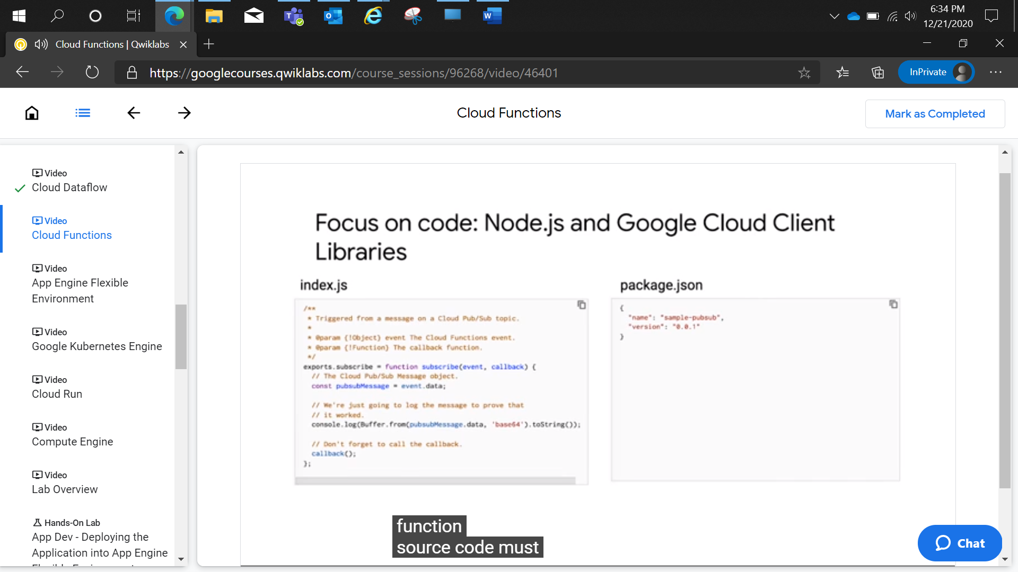

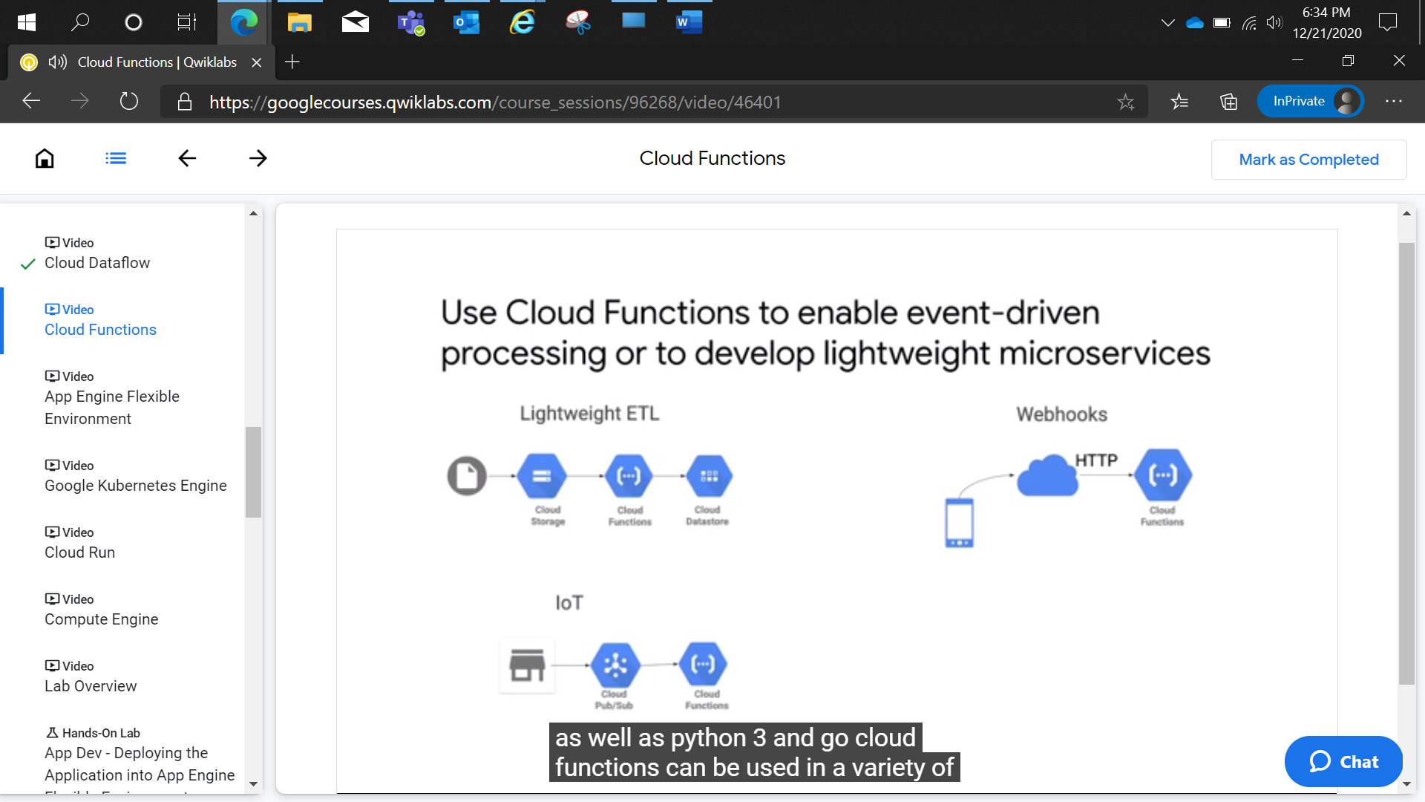

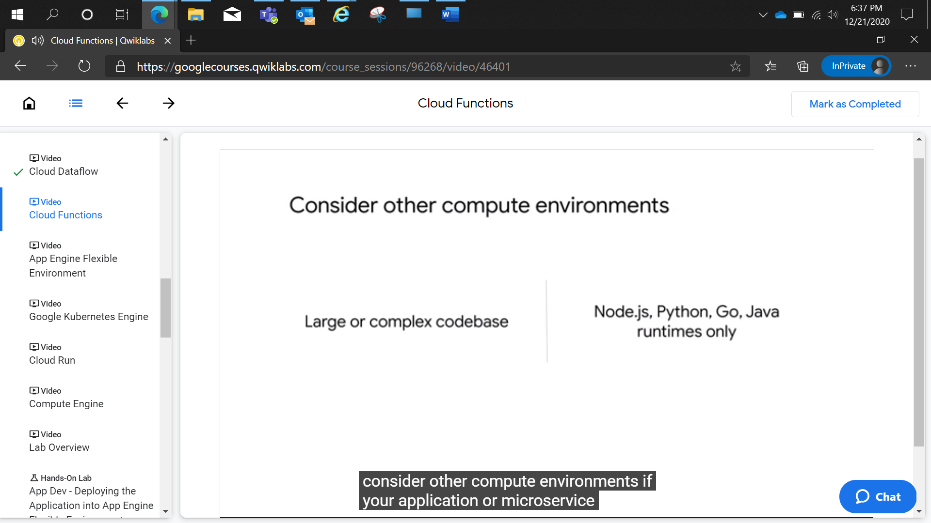

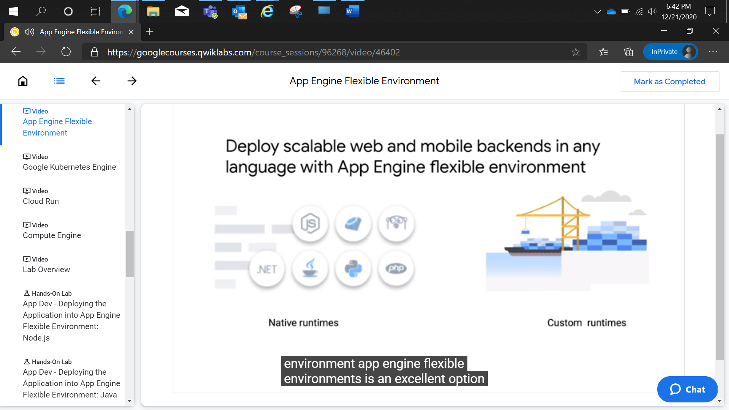

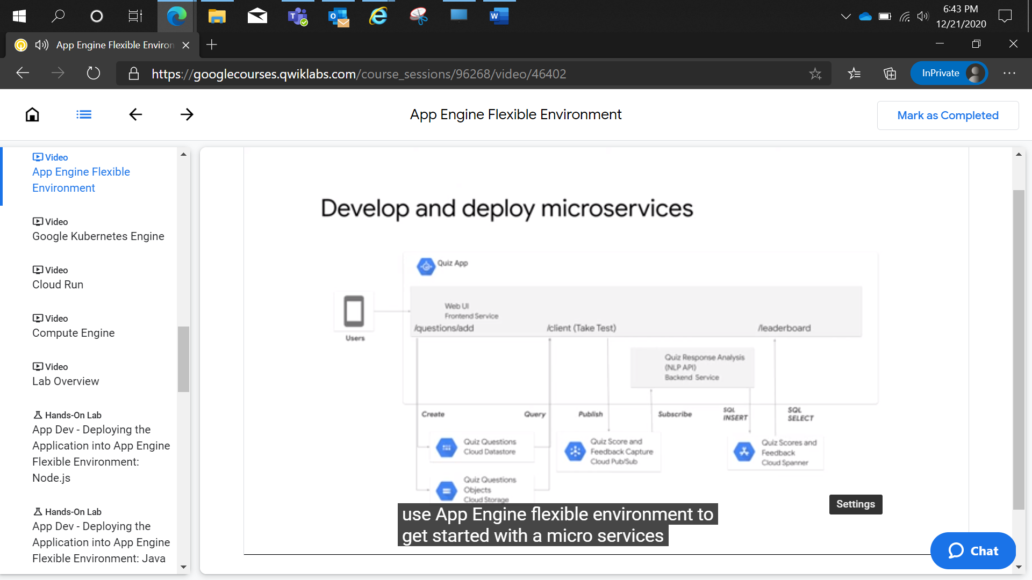

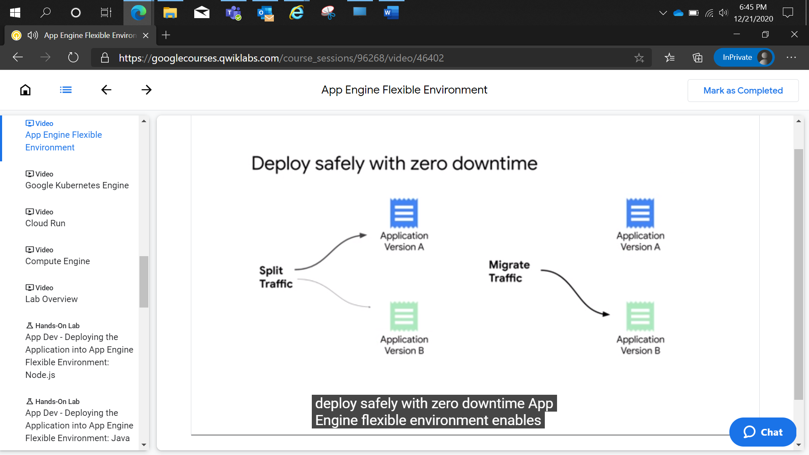

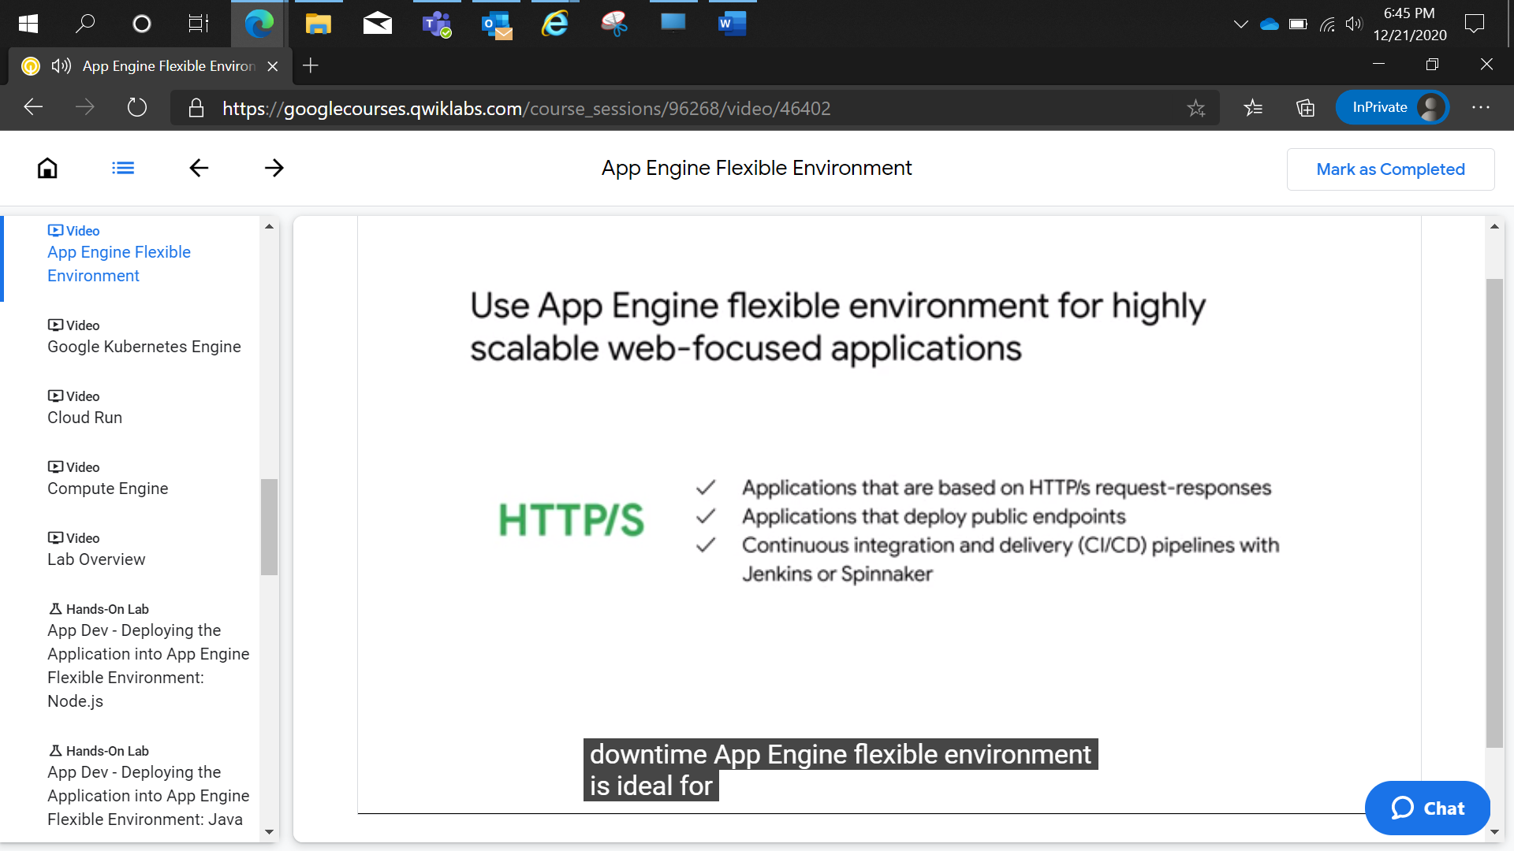

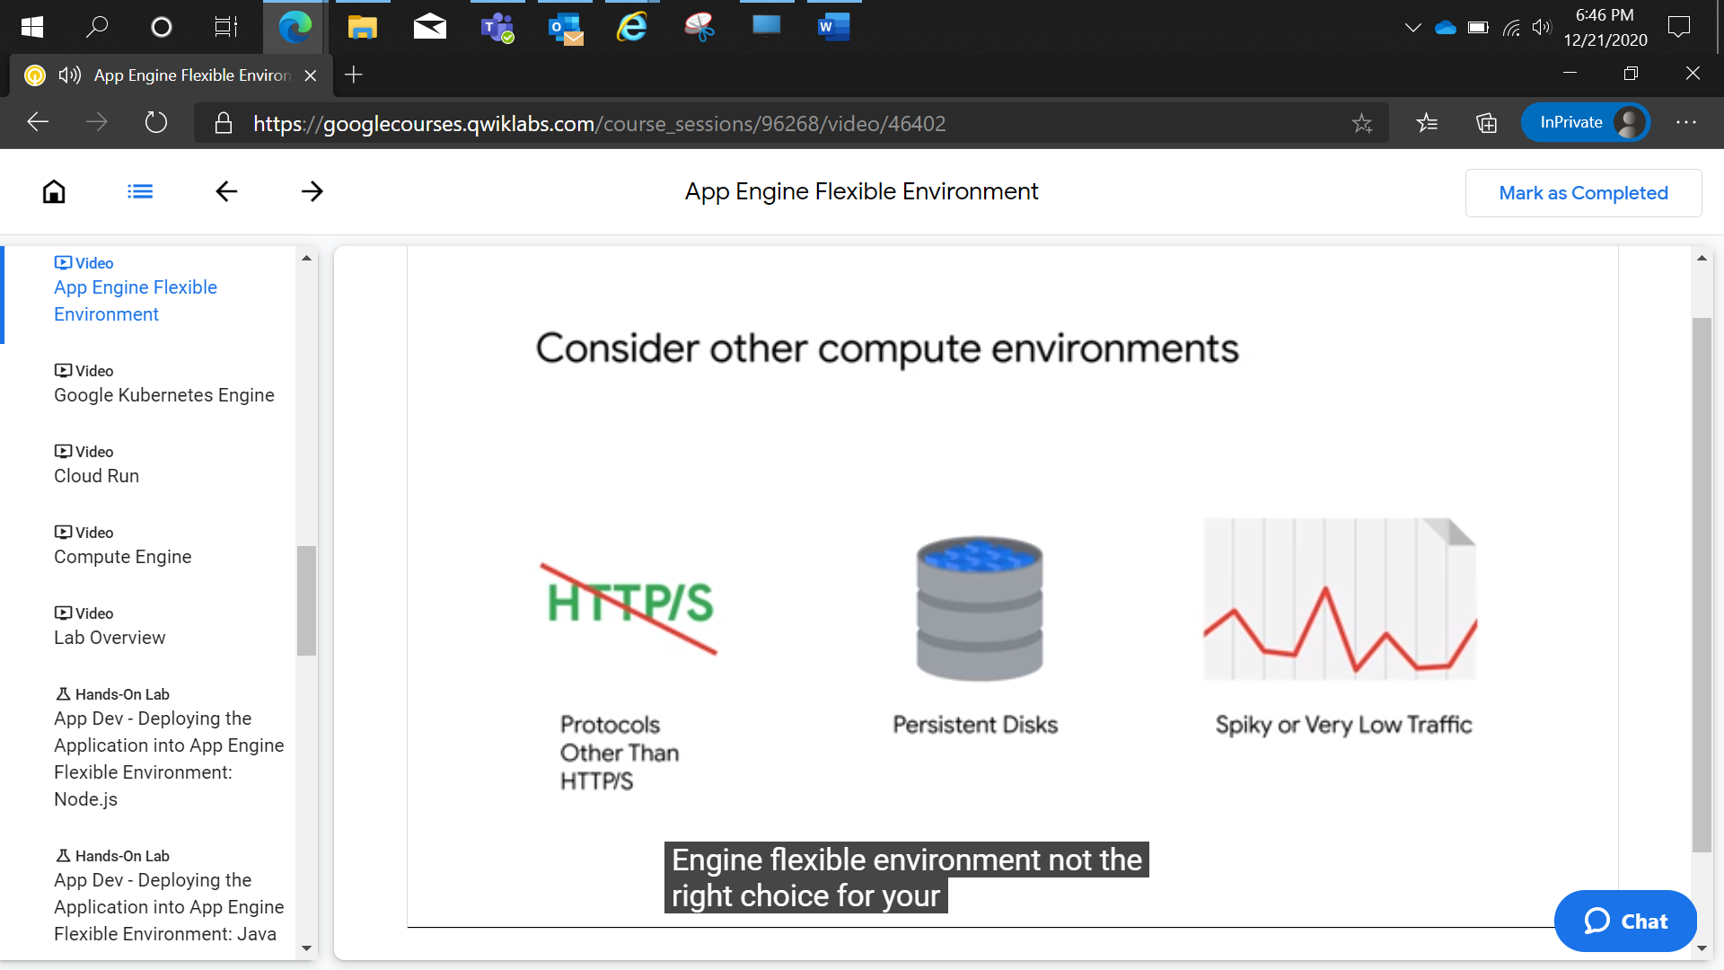

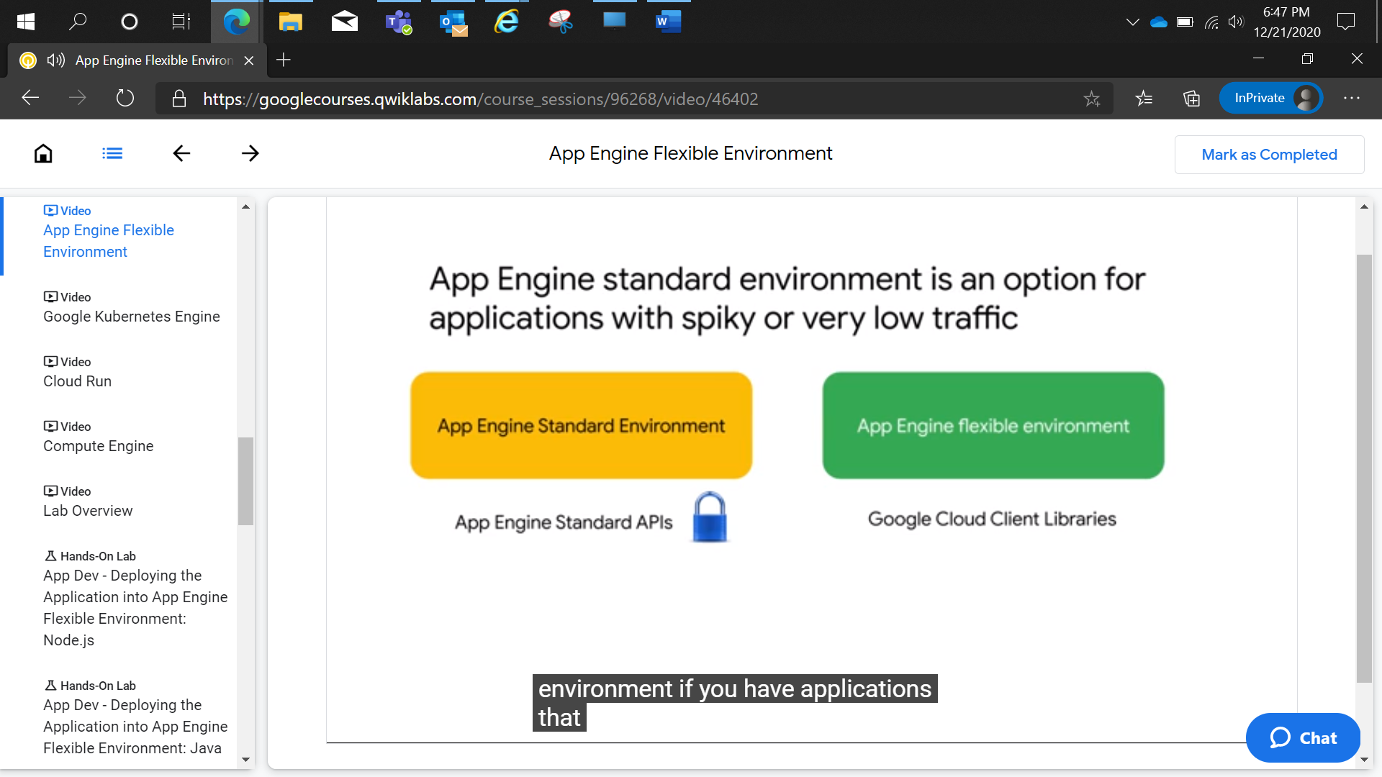

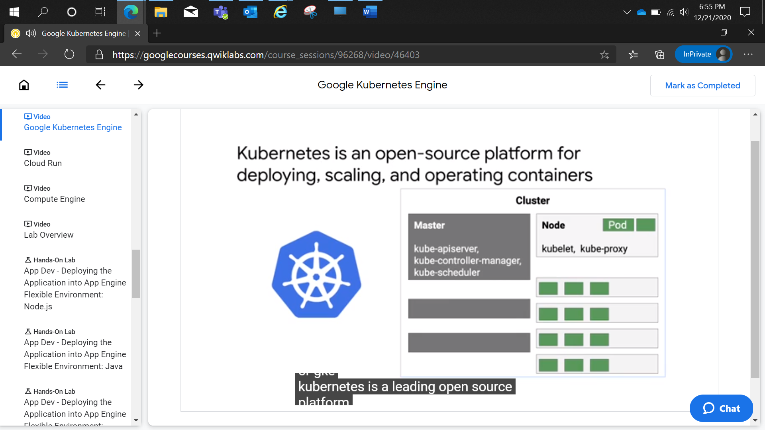

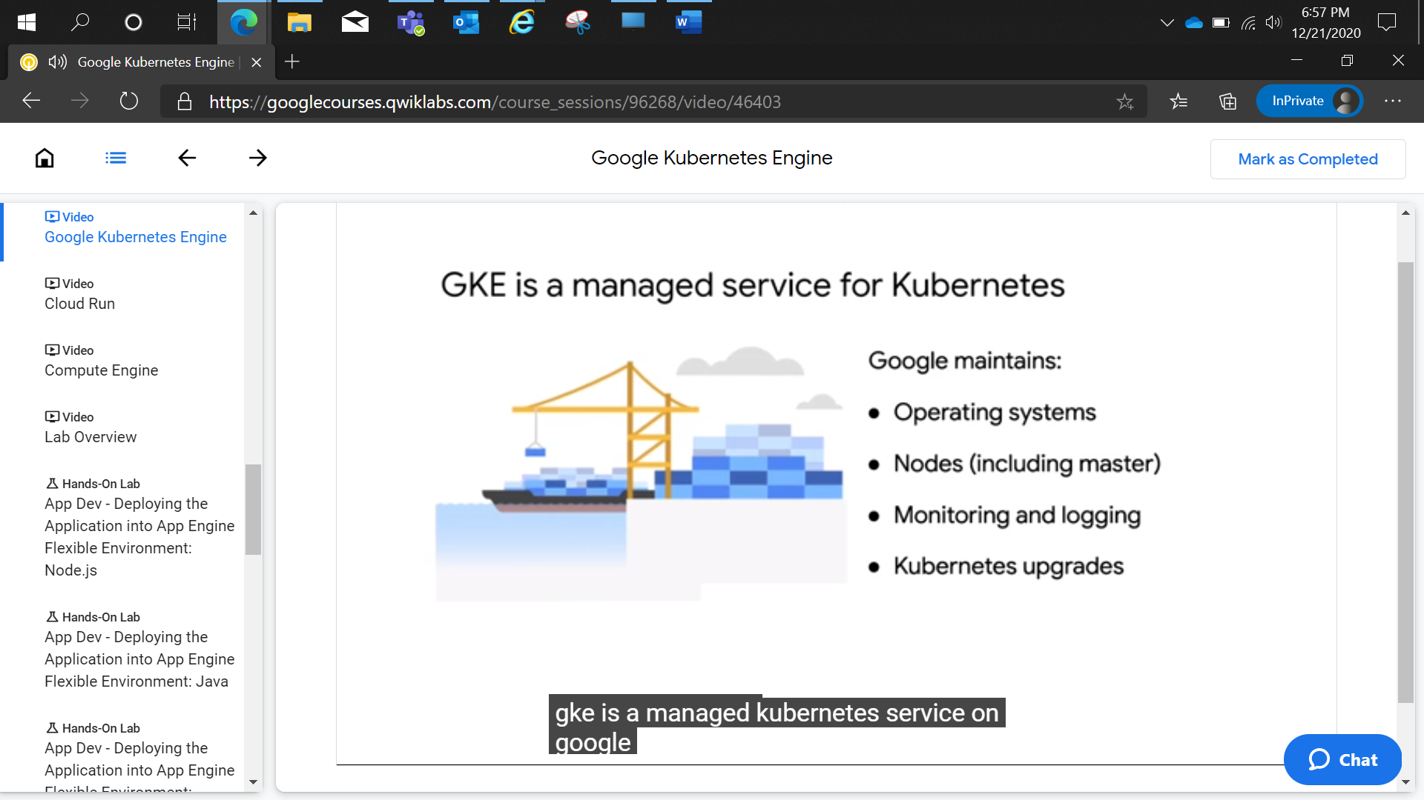

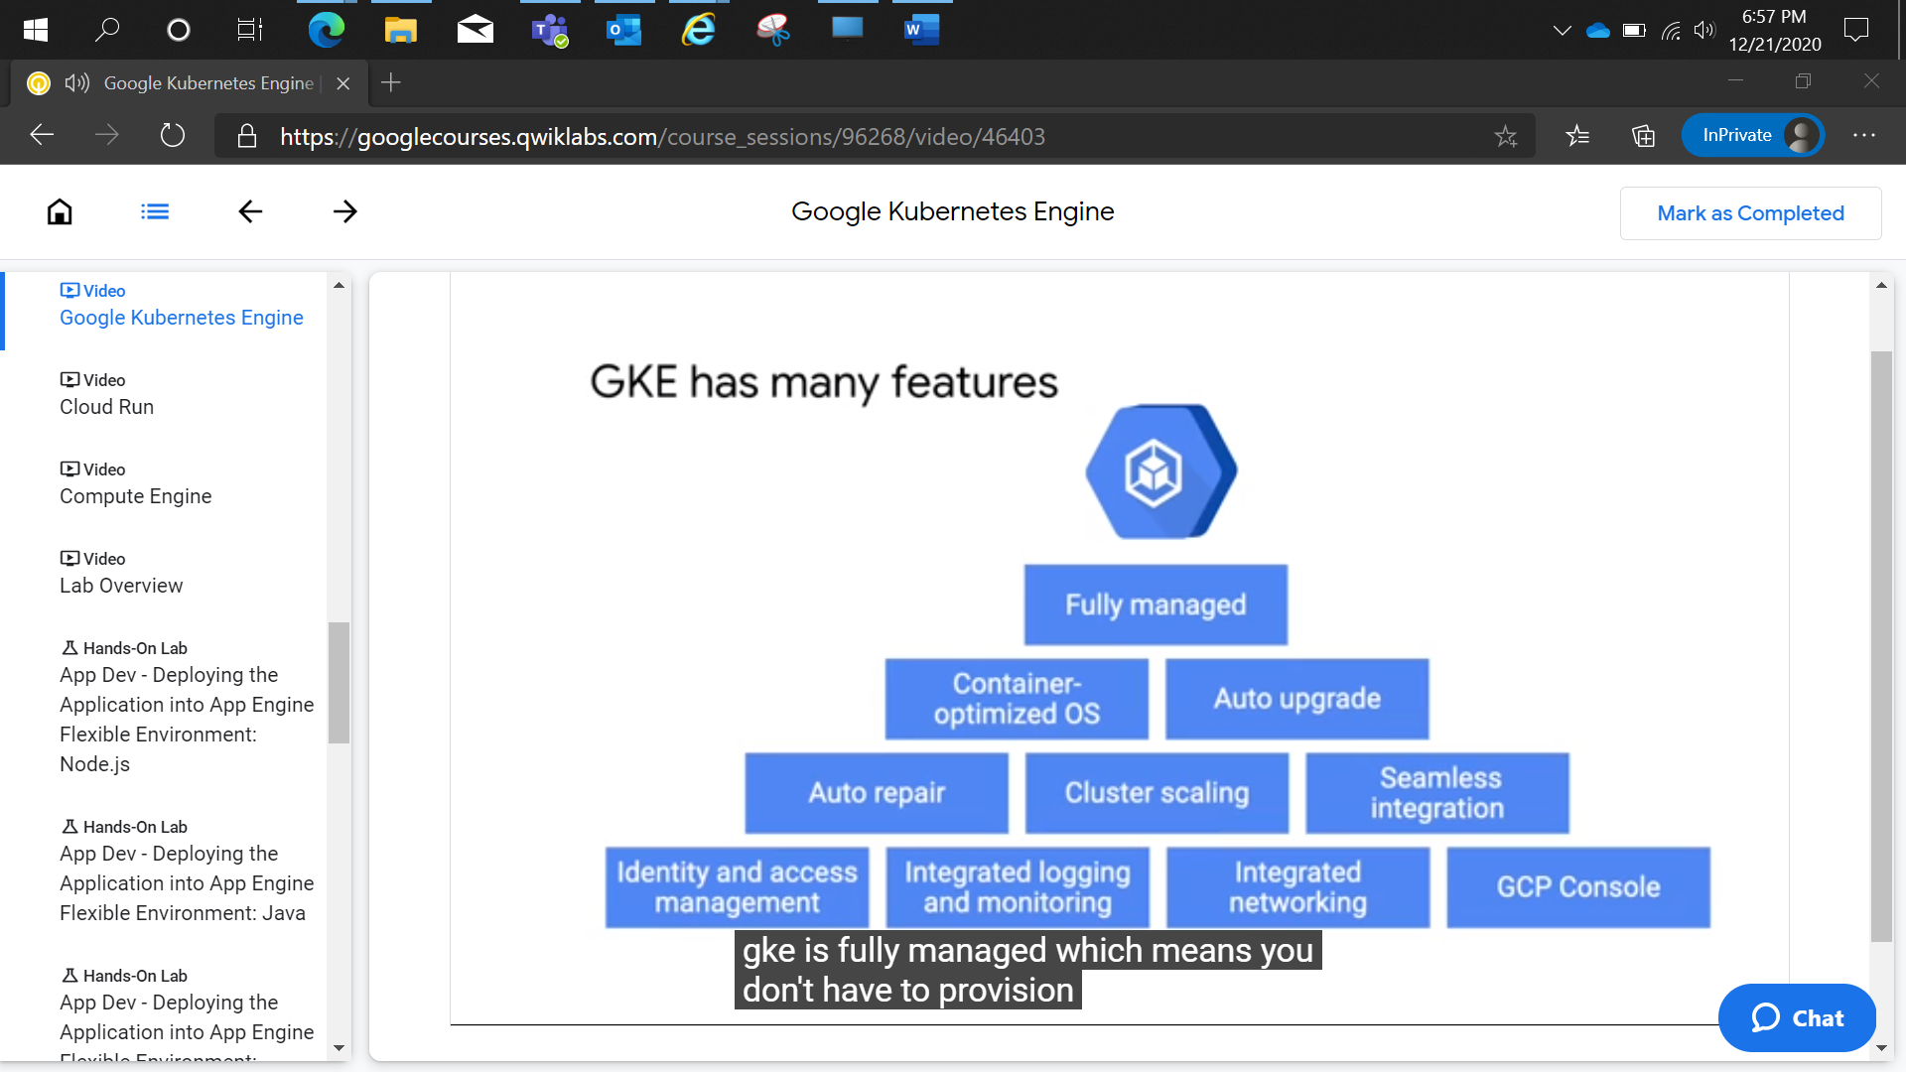

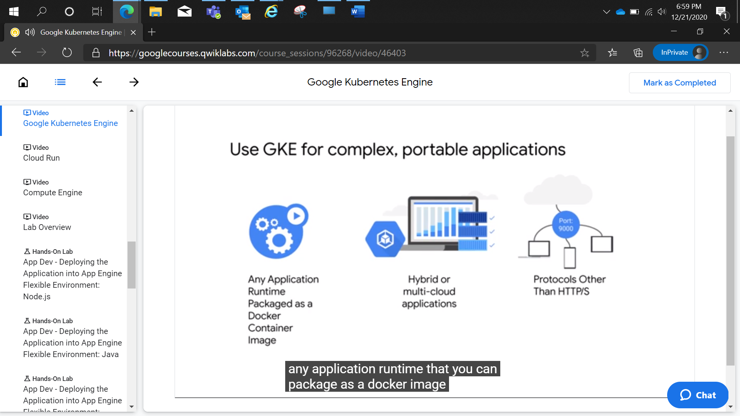

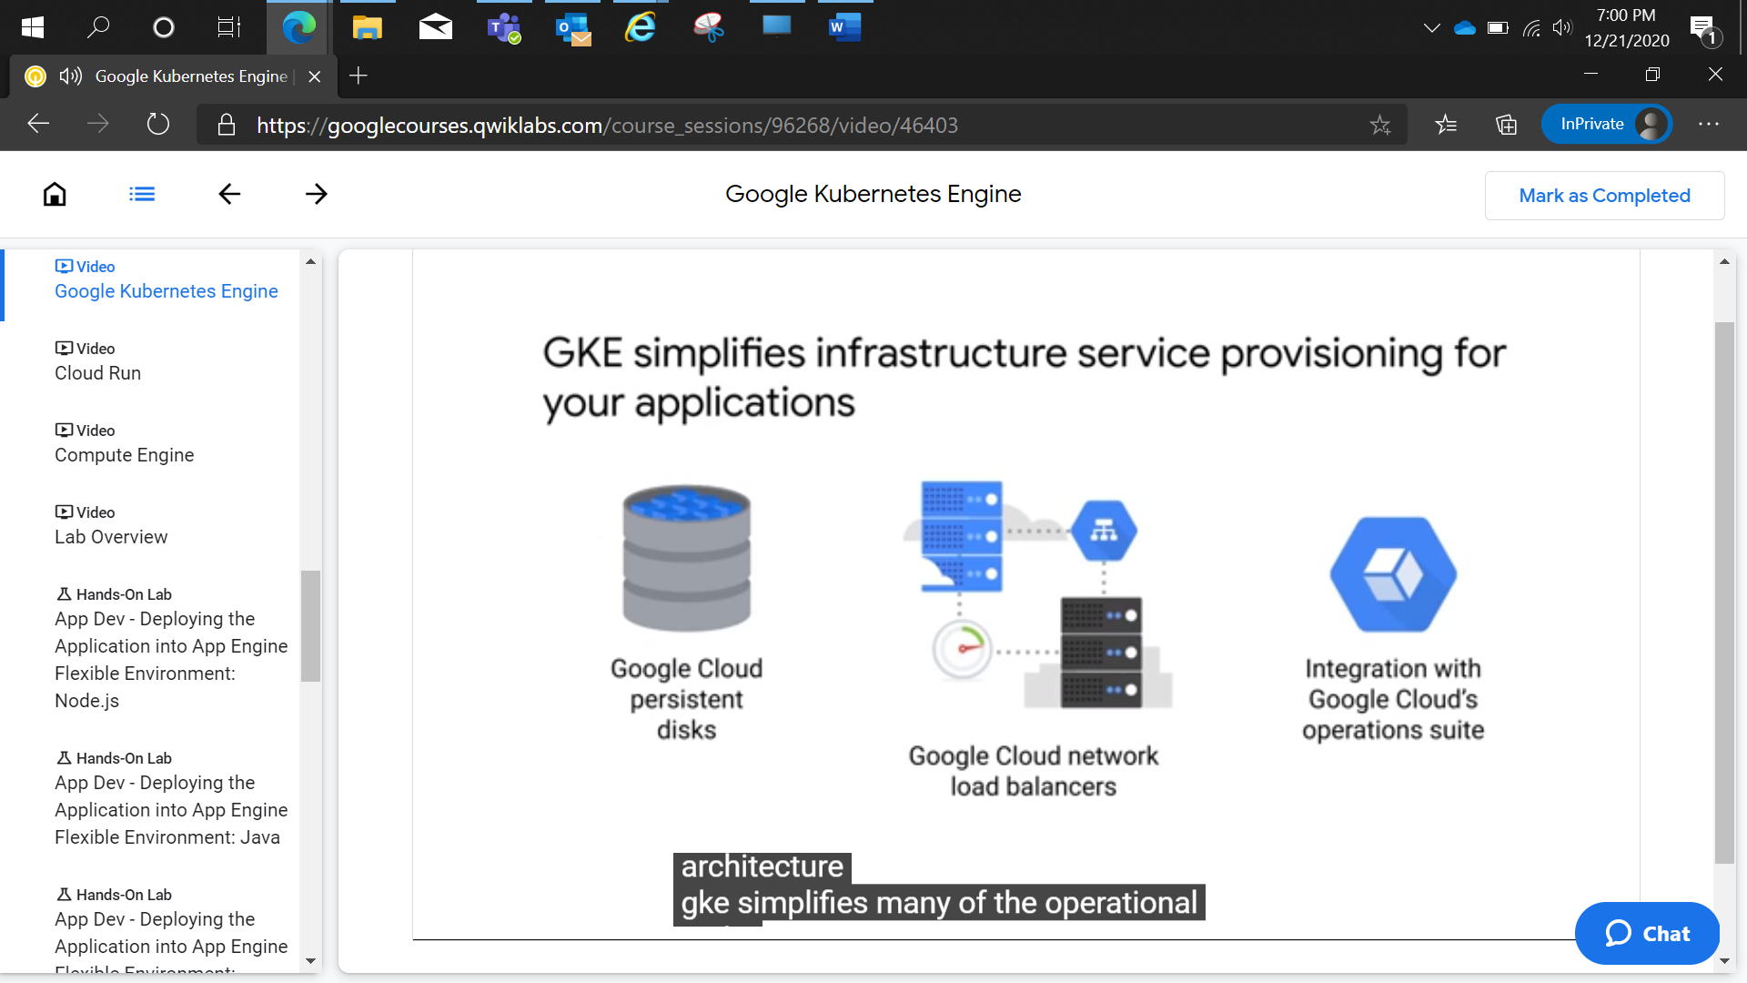

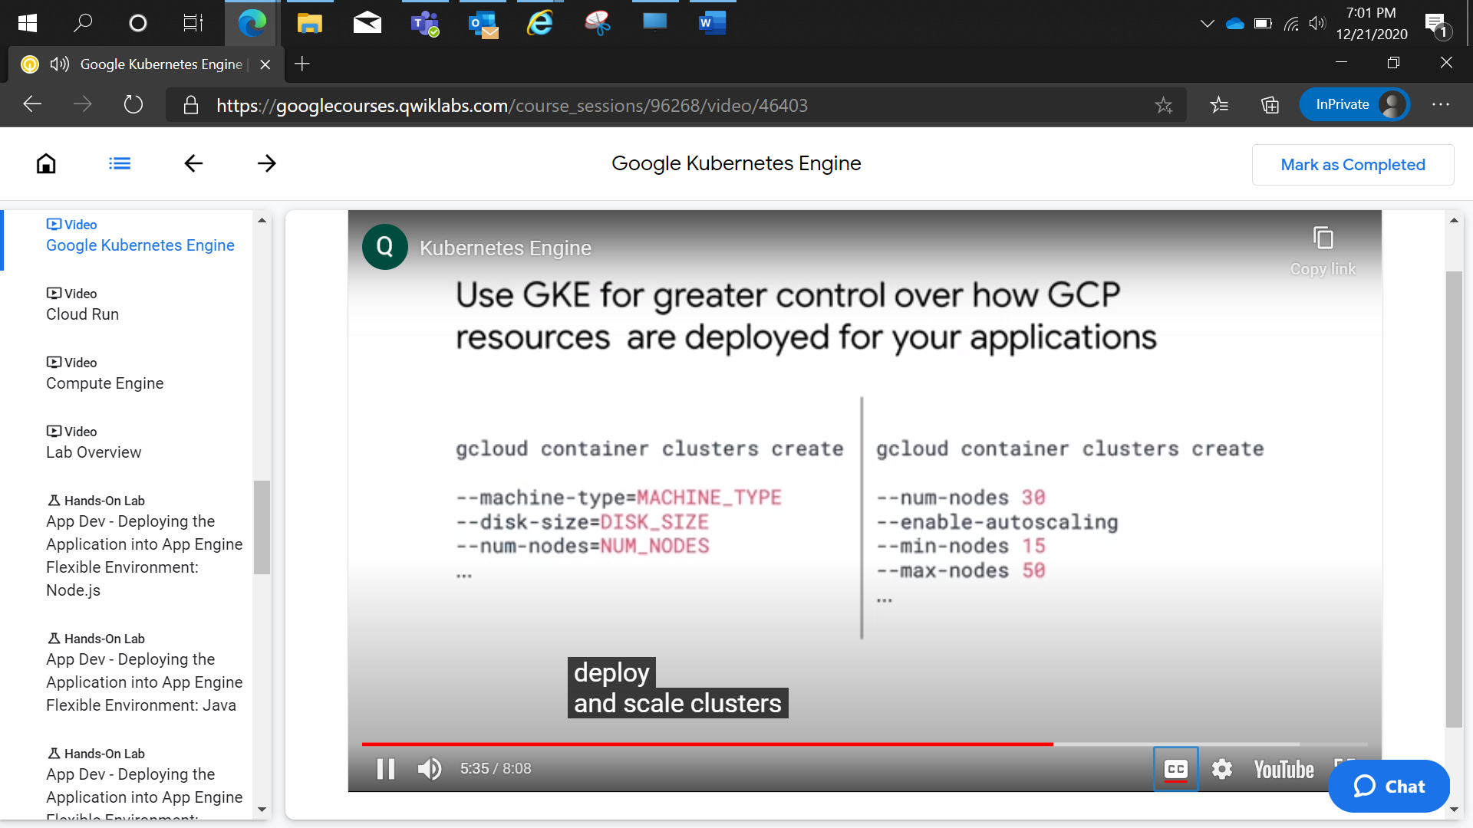

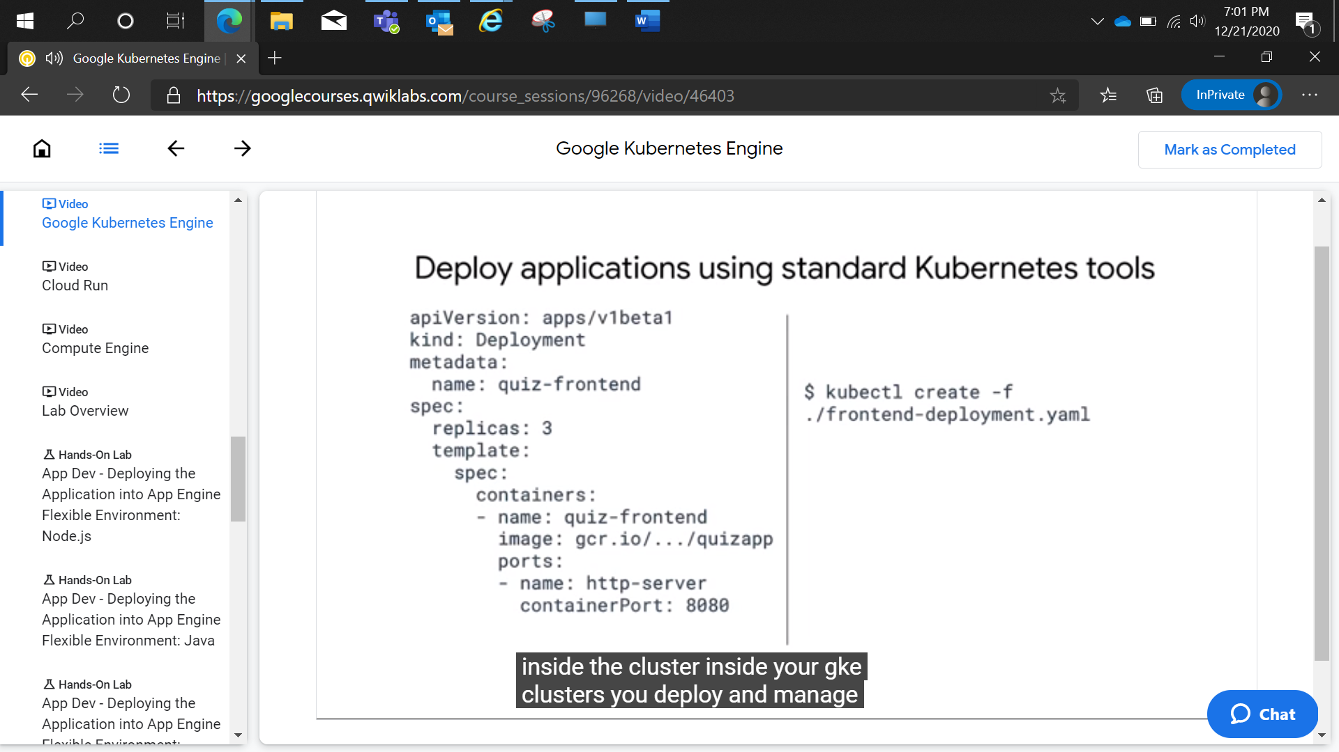

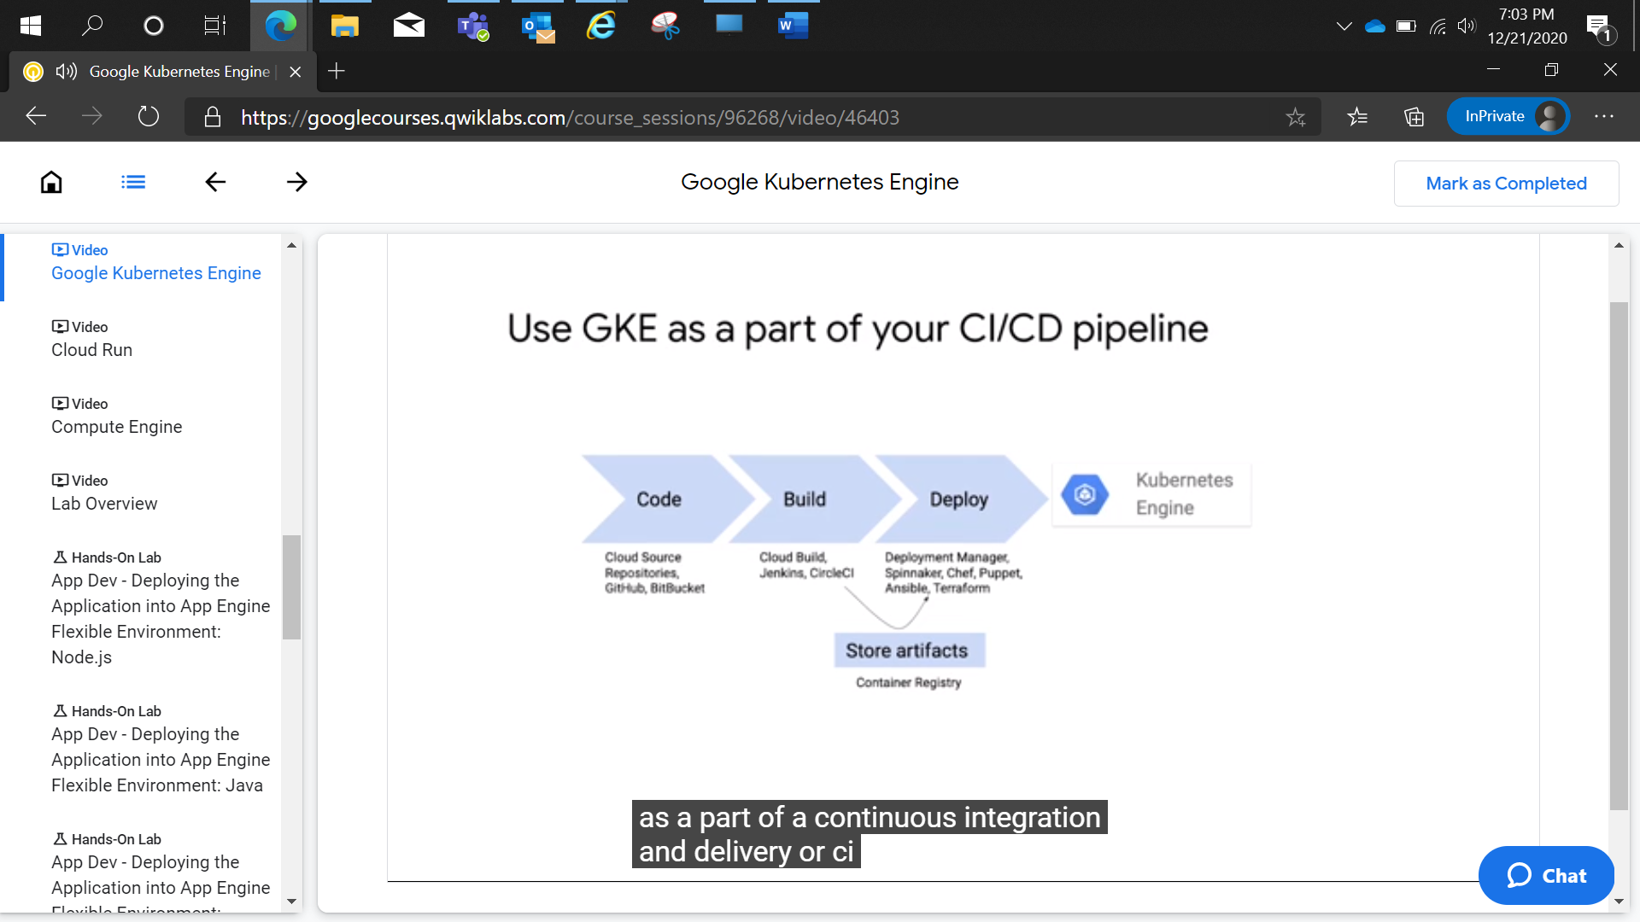

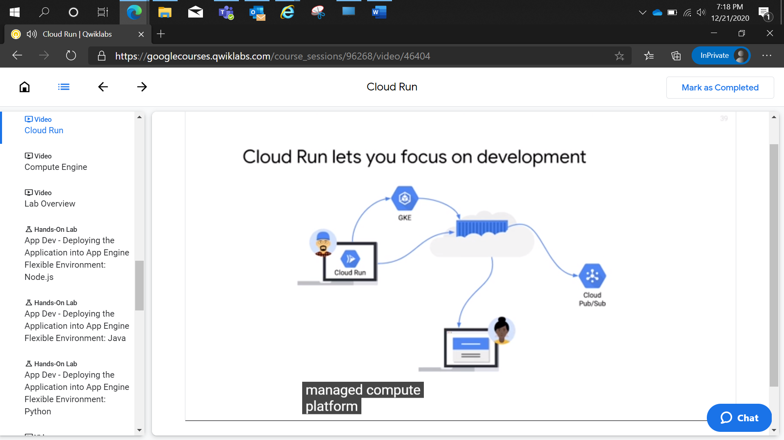

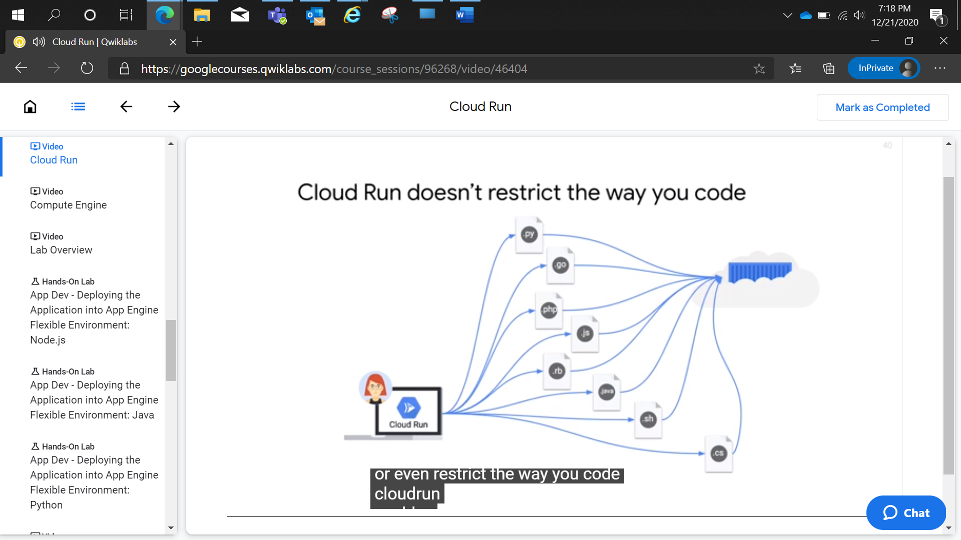

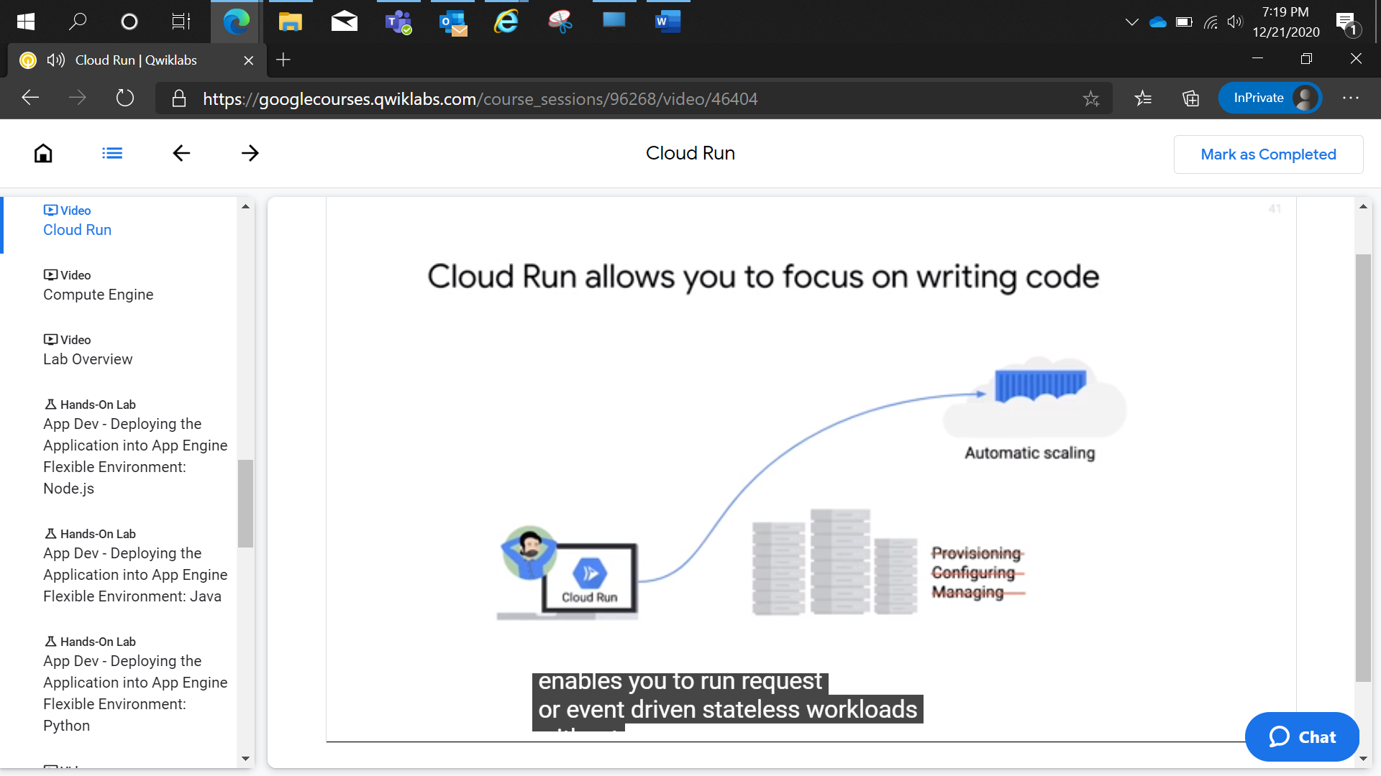

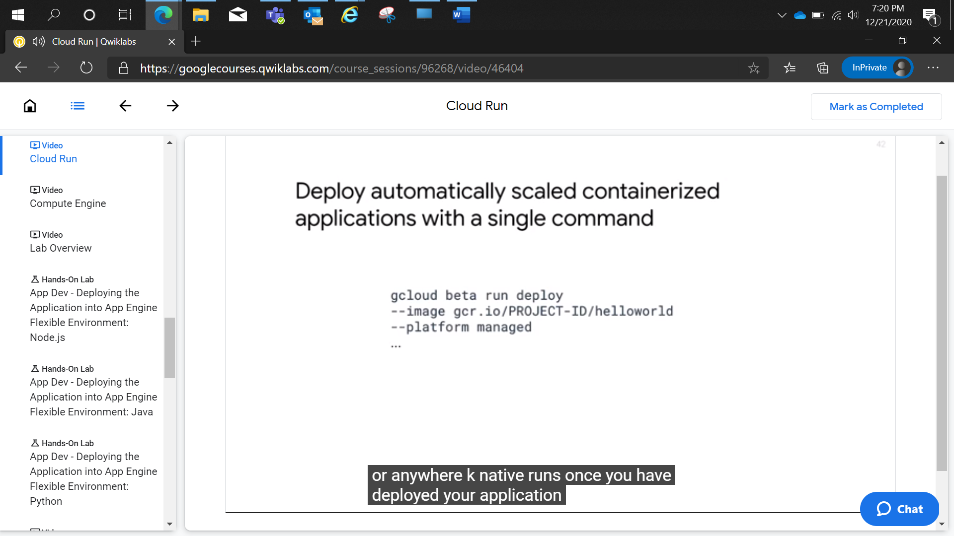

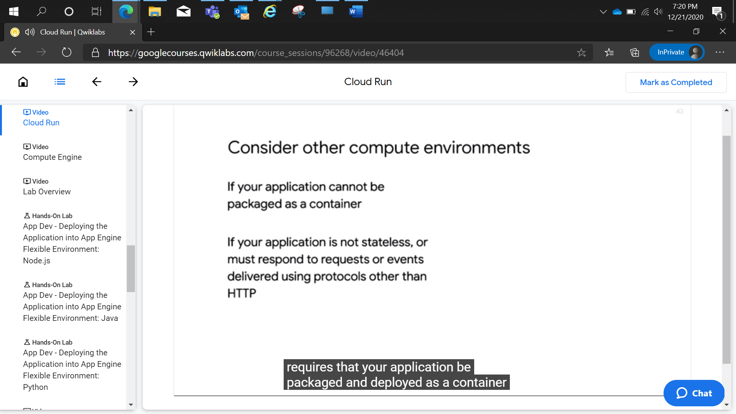

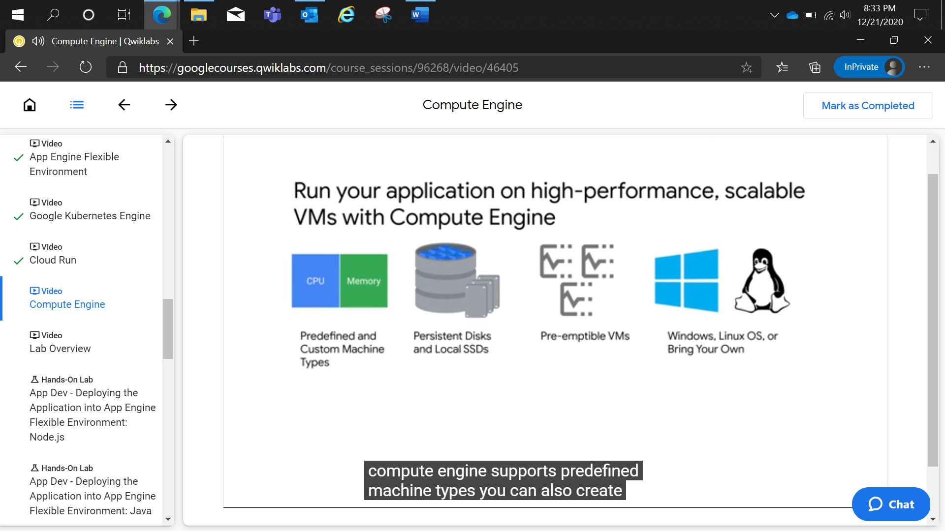

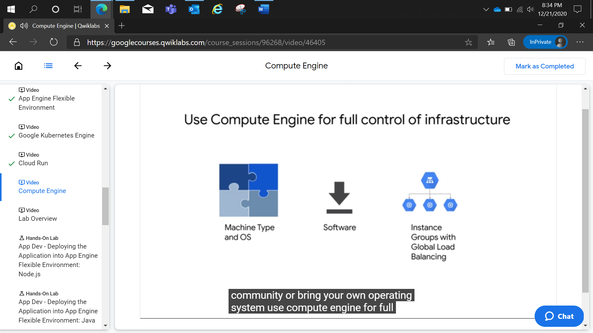

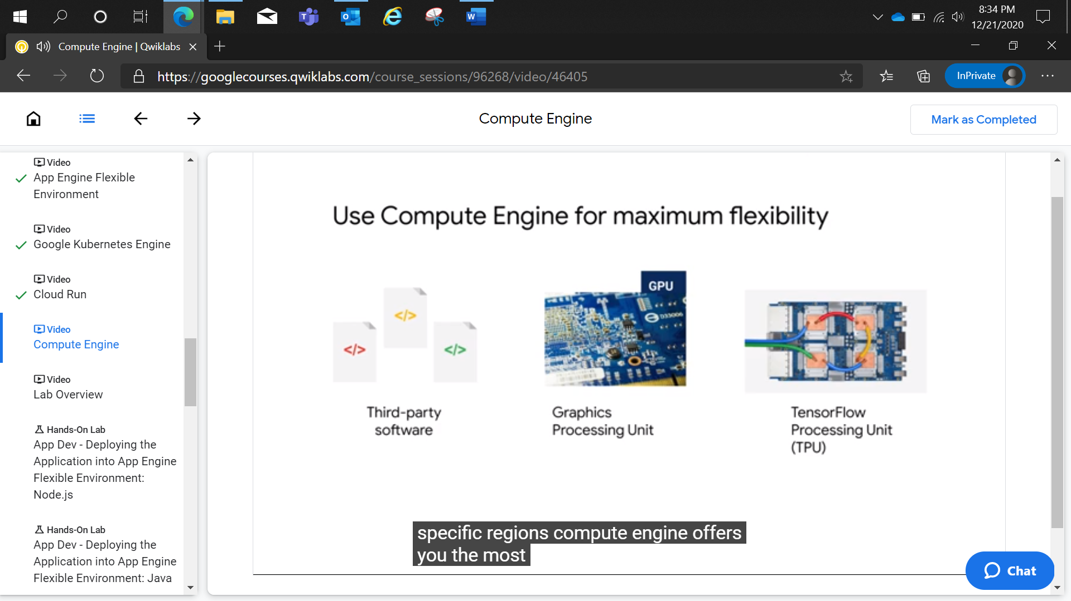

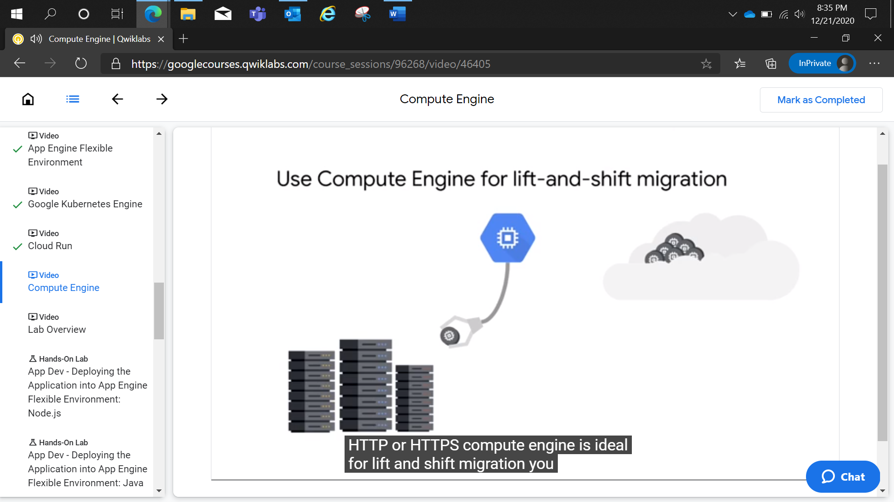

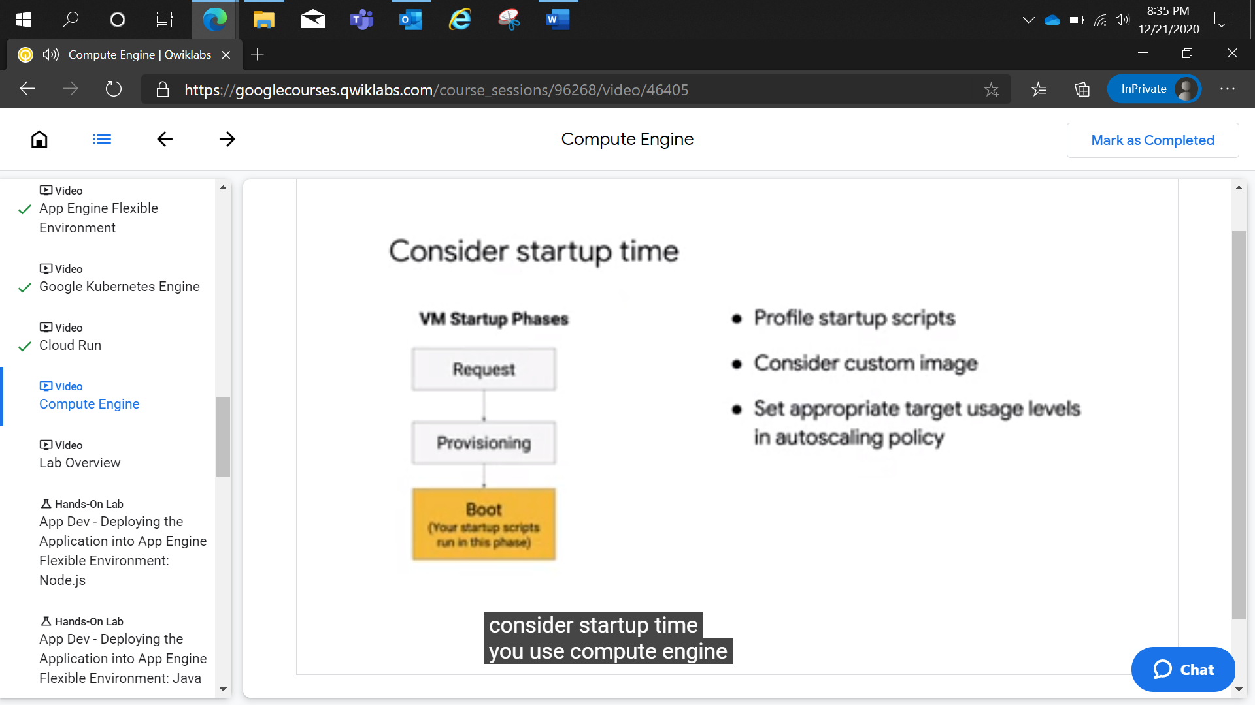

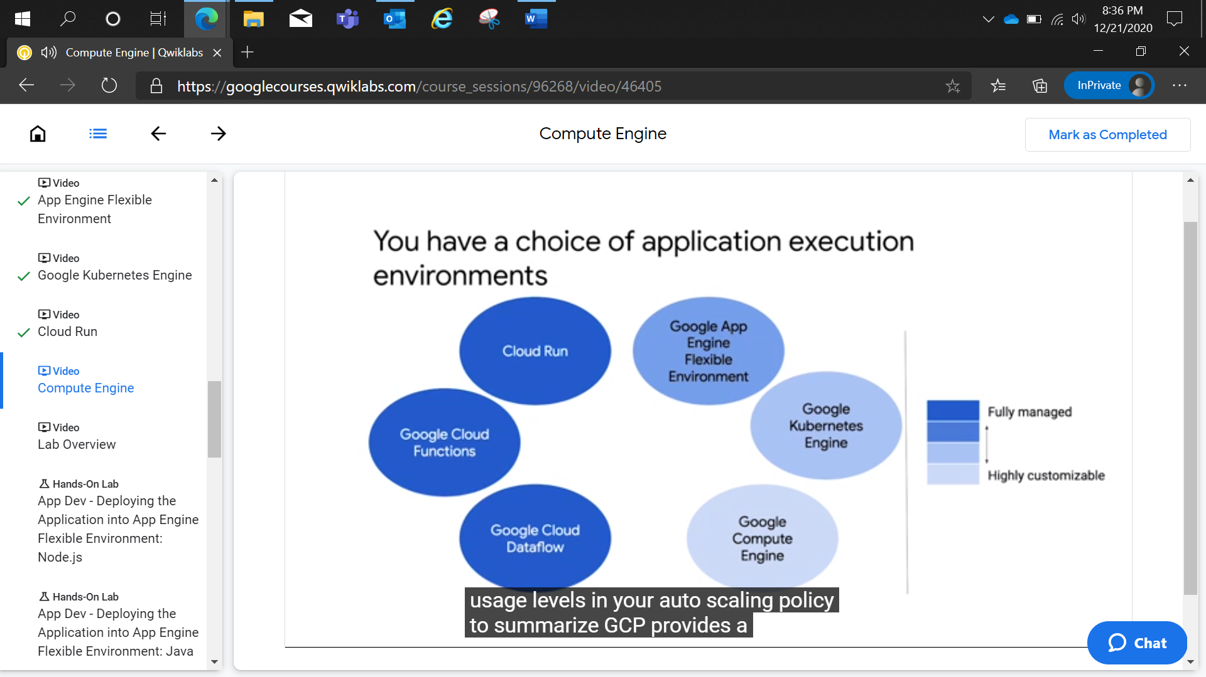

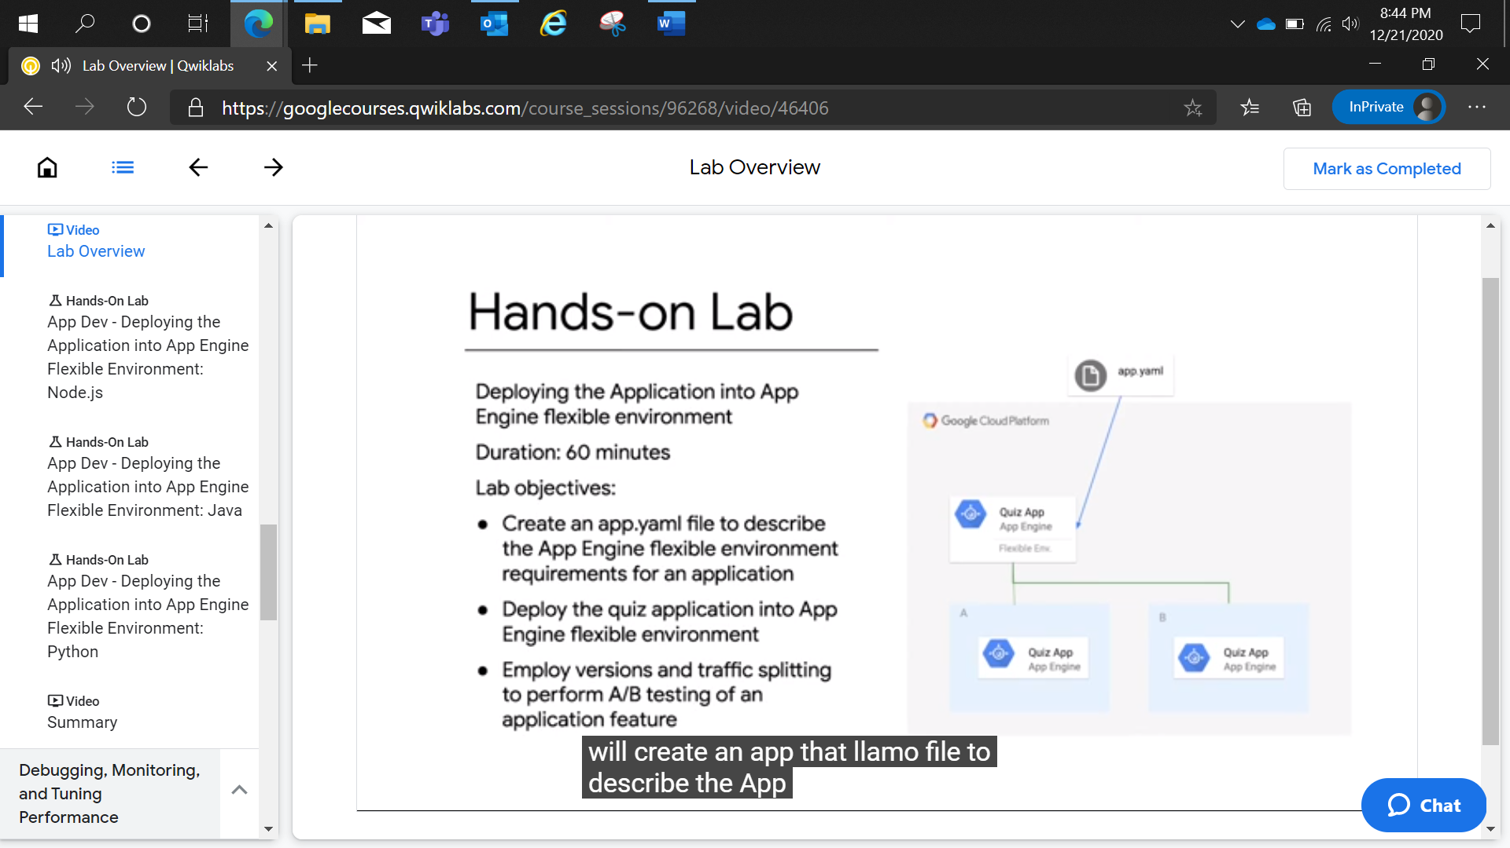

App Dev - Deploying the Application into App Engine Flexible Environment: Java

2 hoursFree

Rate Lab

**Overview**

An App Engine app is a single application resource with one or more services. Each service can be configured to use different runtimes and to operate with different performance settings. Within each service, you can deploy versions of that service, and each then runs within one or more instances, depending on the amount of traffic it's configured to handle. For more information, see [an overview of App Engine](https://cloud.google.com/appengine/docs/flexible/java/an-overview-of-app-engine).

App Engine uses either a standard or flexible environment. A standard environment runs instances in a sandbox, limiting available CPU options and disc access.

In contrast, a flexible environment runs your application in Docker containers on Google Compute Engine virtual machines (VMs), which have fewer restrictions. For example, you can use the programming language or library of your choice, write to disk, and even run multiple processes. You also have the choice of Compute Engine machine types for your instances. For more information about App Engine environments, see [The App Engine Standard Environment](https://cloud.google.com/appengine/docs/standard/) and [App Engine Flexible Environment](https://cloud.google.com/appengine/docs/flexible/).

In this lab, you deploy a quiz application into App Engine flexible environment, and leverage App Engine features like versions and traffic splitting.

**Objectives**

In this lab, you learn how to perform the following tasks:

* Create an app.yaml file to describe the App Engine flexible environment requirements for an application.
* Deploy the quiz application into App Engine flexible environment.
* Employ versions and traffic splitting to perform A/B testing of an application feature.

**Setup and requirements**

**Lab setup**

For each lab, you get a new GCP project and set of resources for a fixed time at no cost.

1. Make sure you signed into Qwiklabs using an **incognito window**.
2. Note the lab's access time (for example, 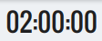 and make sure you can finish in that time block.

There is no pause feature. You can restart if needed, but you have to start at the beginning.

1. When ready, click .
2. Note your lab credentials. You will use them to sign in to Cloud Platform Console. 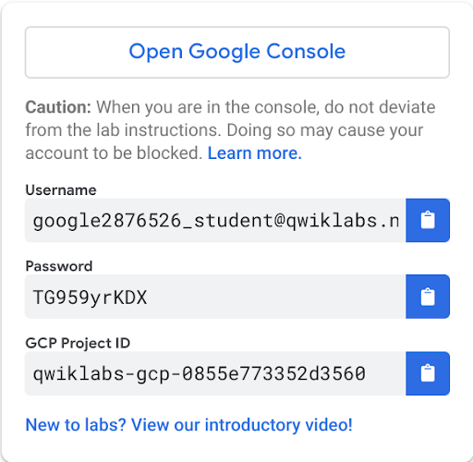
3. Click **Open Google Console**.
4. Click **Use another account** and copy/paste credentials for **this** lab into the prompts.

If you use other credentials, you'll get errors or **incur charges**.

1. Accept the terms and skip the recovery resource page.

Do not click **End Lab** unless you are finished with the lab or want to restart it. This clears your work and removes the project.

Activate Google Cloud Shell

Google Cloud Shell is a virtual machine that is loaded with development tools. It offers a persistent 5GB home directory and runs on the Google Cloud. Google Cloud Shell provides command-line access to your GCP resources.

1. In GCP console, on the top right toolbar, click the Open Cloud Shell button.

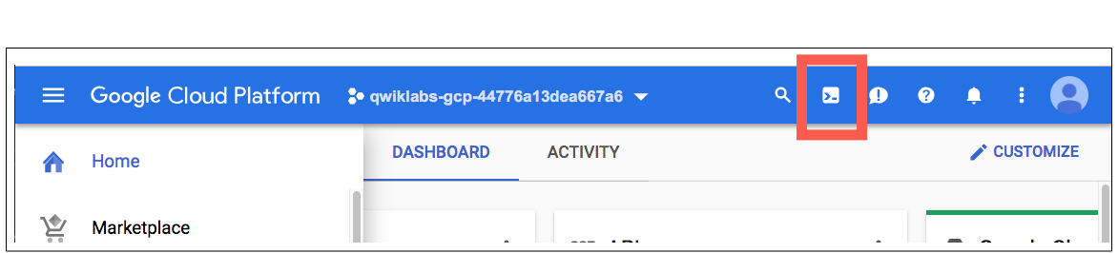

1. Click **Continue**. 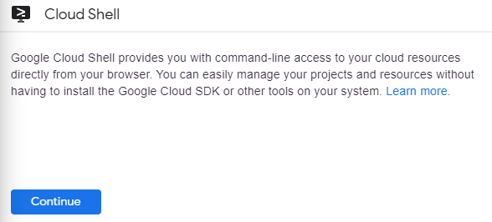

It takes a few moments to provision and connect to the environment. When you are connected, you are already authenticated, and the project is set to your *PROJECT_ID*. For example:

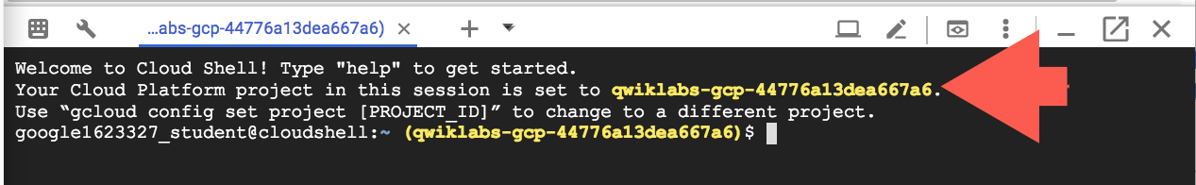

**gcloud** is the command-line tool for Google Cloud Platform. It comes pre-installed on Cloud Shell and supports tab-completion.

You can list the active account name with this command:

gcloud auth list

content_copy

Output:

Credentialed accounts:

- <myaccount>@<mydomain>.com (active)content_copy

Example output:

Credentialed accounts:

- google1623327_student@qwiklabs.netcontent_copy

You can list the project ID with this command:

gcloud config list project

content_copy

Output:

[core]

project = <project_ID>content_copy

Example output:

[core]

project = qwiklabs-gcp-44776a13dea667a6content_copy

Full documentation of **gcloud** is available on [Google Cloud gcloud Overview](https://cloud.google.com/sdk/gcloud).

**Preparing the case study application**

In this section, you access Cloud Shell, clone the git repository that contains the Quiz application, configure environment variables, and run the application.

Clone source code in Cloud Shell

1. Enter the following command to clone the repository for the lab.

git clone https://github.com/GoogleCloudPlatform/training-data-analyst

content_copy

1. Create a soft link to your working directory:

ln -s ~/training-data-analyst/courses/developingapps/v1.2/java/appengine ~/appenginecontent_copy

Configure the case study application

Change to the directory that contains the sample files for this lab:

cd ~/appengine/start

content_copy

Run the executable file by by running the following command:

. prepare_environment.sh

content_copy

This script file

* Creates an App Engine application.
* Creates a Cloud Storage bucket.
* Exports environment variables GCLOUD_PROJECT and GCLOUD_BUCKET.
* Runs mvn clean install.
* Creates entities in Datastore.
* Creates a Pub/Sub topic.
* Creates a Spanner Instance, Database, and Table.
* Creates a Cloud Function.
* Prints out the Project ID.

Review the code

In this lab you view and edit files. You can use the shell editors that are installed on Cloud Shell, such as nano or vim, or use the Cloud Shell code editor. This lab uses the Cloud Shell code editor.

**Launch the Cloud Shell Editor**

In the Cloud Platform Console, click **Open Editor**. This icon looks like a pencil.



You can return later to terminal with **Open Terminal**.

Navigate to **training-data-analyst/courses/developingapps/v1.2/java/appengine/start**.

The folder structure for the quiz application reflects how it will be deployed in App Engine.

There is a configuration file for App Engine; app.yaml in a new folder, src/main/appengine.

**Preparing application code for App Engine flexible environment deployment**

In this section, you modify the configuration files for deployment of the quiz application frontend into App Engine flexible environment.

Create the app.yaml file for the frontend

In the Cloud Shell code editor, open src/main/appengine/app.yaml.

The following content describes the App Engine configuration. Copy and paste the content into app.yaml. Be sure you replace [GCLOUD_BUCKET] with the actual bucket name GCLOUD_PROJECT-media from your project. GCLOUD_PROJECT is your GCP Project ID.

**src/main/appengine/app.yaml**

runtime: java

env: flex

runtime_config:

jdk: openjdk8

handlers:

- url: /.*

script: this field is required, but ignored

manual_scaling:

instances: 1

resources:

cpu: 1

memory_gb: 3.75

disk_size_gb: 10

env_variables:

GCLOUD_BUCKET: [GCLOUD_BUCKET]

content_copy

Save the file.

Deploy the quiz application to App Engine flexible environment

In Cloud Shell, **Open Terminal**, enter the following command to deploy the quiz application to App Engine flexible environment.

mvn package appengine:deploy \

-Dapp.deploy.projectId=$GCLOUD_PROJECT \

-Dapp.deploy.version=1

content_copy

It may take around 7-10 minutes to complete the deployment.

Maven rebuilds the project and then invokes gcloud app deploy. App Engine automatically packages, containerizes, and deploys the code.

You'll see output similar to the following when the deployment is complete:

INFO\] ----------------------------------------------------------------

\[INFO\] BUILD SUCCESS

\[INFO\] --------------------------------------------------------------

\[INFO\] Total time: 10:21 min

\[INFO\] Finished at: 2018-05-23T19:28:50-04:00

\[INFO\] --------------------------------------------------------------

content_copy

In the Cloud Platform Console, on the **Navigation menu** > **App Engine** > **Dashboard.**

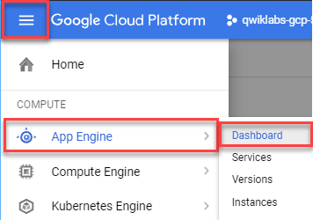

Click on the link to your application in the top-right corner of the App Engine Dashboard to see your application, the Quite Interesting Quiz.

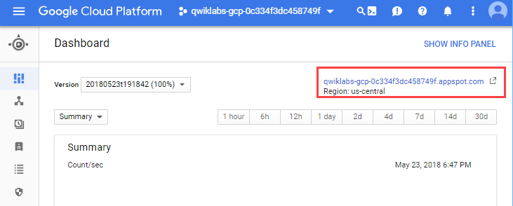

**Updating an App Engine flexible environment application**

In this section, you will modify the application code and then redeploy the application.

Update the quiz application

In the Cloud Shell code editor, **Open Editor**, open the src/main/resources/static/index.html file. Add several exclamation points to the top-level heading.

**src/main/resources/static/index.html**

<!-- This is just a fragment, only add the exclamation points -->

<div class="container">

<h1>Welcome to the Quite Interesting Quiz!!!!!</h1>

<div class="jumbotron">

<p>Welcome to the Quite Interesting Quiz where you can create a question, take a test or review feedback</p>

</div>

content_copy

This small change stands in for all the changes you might make when updating an application.

Click **File > Save** to save the file.

Deploy the updated application

In **Cloud Shell**, **Open Terminal**, redeploy the App Engine application.

mvn package appengine:deploy \

-Dapp.deploy.projectId=$GCLOUD_PROJECT \

-Dapp.deploy.version=2 \

-Dapp.deploy.stopPreviousVersion=False \

-Dapp.deploy.promote=Falsecontent_copy

Notice the two additional flags in the command, which means that the previous version will continue to receive traffic.

It may take around 4-10 minutes for the deployment to update.

In the Console, click **Navigation menu** > **App Engine** > **Dashboard**.

Click on the application URL in the top-right corner of the window. You should see that your application still displays the old title.

In the **App Engine** window, click **Versions**. You may need to refresh the page until you see two versions of the applications.

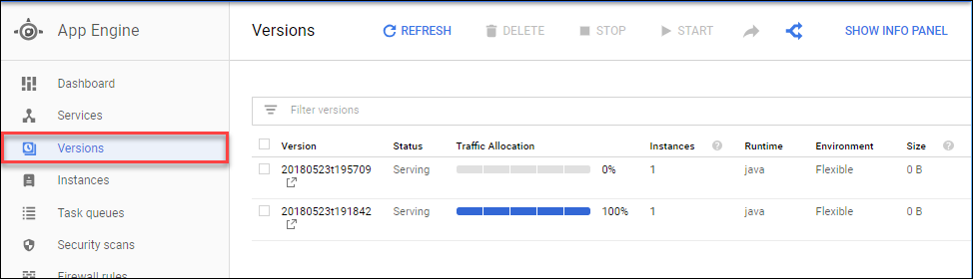

Click on both version links to see the new and old version of the quiz application.

New version (notice those exclamation points!):

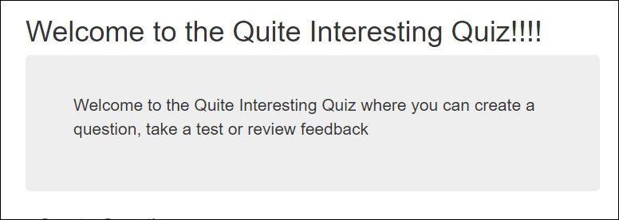

Old version:

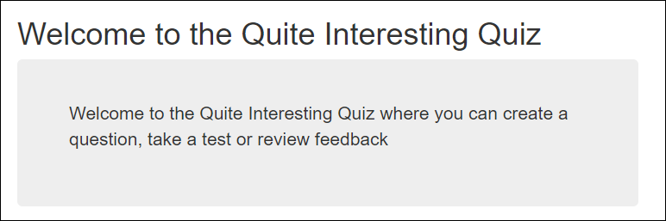

Enable the checkbox for both versions of the application, and click **Split traffic**.

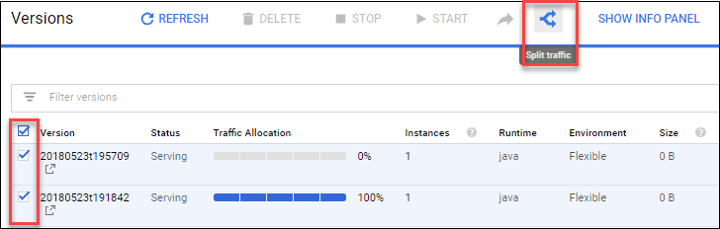

Select the radio button to deliver versions randomly.

Configure the traffic split to deliver 50% of traffic to the old version, and 50% to the new version.

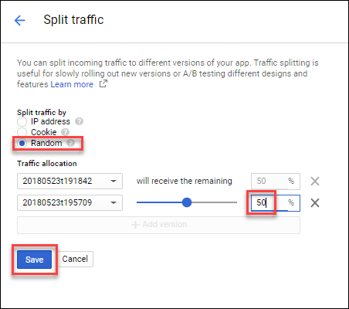

Click **Save**.

Return to the **Dashboard**, set **Version** to All versions and click the application link.

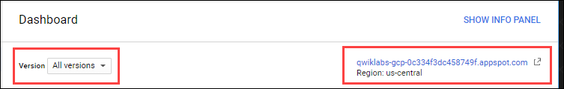

Open a **new browser**. If possible the browser should be a different type, for example Google Chrome to Internet Explorer. Copy the application link and paste it in the new browser.

Refresh the homepage a few times.

You should see that the homepage displays the old version approximately half the time, and the new version half the time.

In real-world scenarios, you might start by delivering small amounts of traffic to the new version in a canary release, and would use either a cookie or IP address to ensure that a client viewed a single consistent version of the application.

